Software Requirements Specification

AI Code reviewing and
mentoring System
Table of Content

1.0. Introduction 3
1.1. Purpose 3
1.2 Scope of the project 3
1.3 Glossary 3
1.4 References 3
1.5. Overview of Document 3
2.0 Overall Description 4
2.1 System Environment 4
2.2 Functional Requirement Specifications 5
2.3 User Characteristics 6
2.4 Non Functional Requirement 6
3.0 Requirement Specification 7
3.1 External Interface Requirements 7
3.2 Functional Requirements 7

1.0. Introduction

1.1. Purpose
The purpose of this document is to present a detailed description of an AI code reviewing and mentoring system. It explains the purpose and features of the system, the interface, what it does, how it does it.
Problem statement-

1.2 Scope of the project
The system is an AI code reviewer and mentor. The system is intended to help students improve their programming skills, by providing them accurate feedback on their thought process and approach, and highlighting the drawbacks of it, which will prompt them to brainstorm new solutions which will lead to them eventually writing better code, and developing algorithmic intuition.
More specifically the system is designed to help students learn problem solving in programming concepts (Data structures and Algorithms) by giving them constant feedback, resolving any misconceptions in their thought processes prompts for improvisation.

1.3 Glossary
Analysis | A description of strengths and weaknesses of the code written by the user(student).
Log | Recorded data of coding activity, including modifications, and time spent.
Time Spent | Duration the student spends on a specific line of code.
Approach | The thought process of the student while solving the question, and his way to solve the question
Problem | The coding problem the student will be attempting to solve.

1.4 References
IEEE. IEEE Std 830-1998 IEEE Recommended Practice for Software Requirements Specifications. IEEE Computer Society, 1998.

1.5. Overview of Document
The next chapter, the Overall Description section, of this document gives an overview of the functionality of the product. It describes the informal requirements and is used to establish a context for the technical requirements specification in the next chapter.
The third chapter, Requirements Specification section, of this document is written primarily for the developers and describes in technical terms the details of the functionality of the product.

2.0 Overall Description

2.1 System Environment
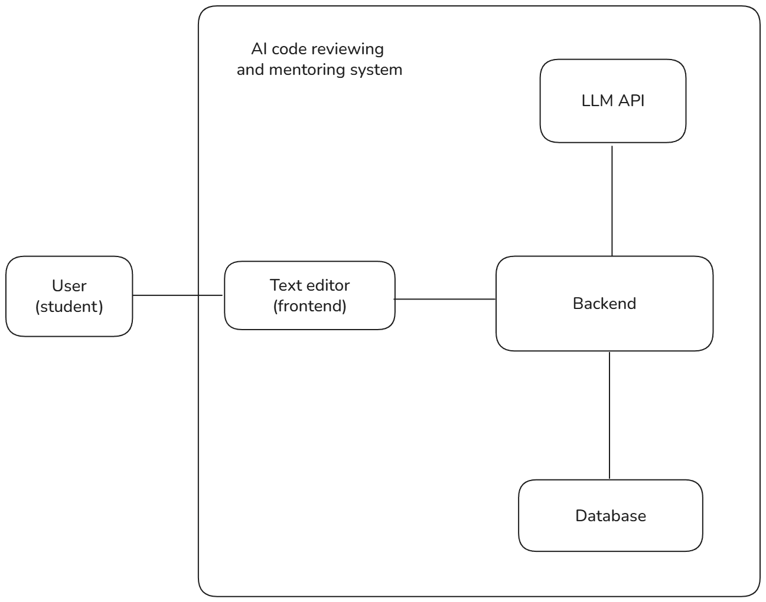

The system consists of 4 components: Text editor (i.e. frontend) , LLM, Backend & Database. The user does all its interactions with the text editor, it is where the student writes their code and gets their response from the backend. Backend will handle flow of data between text editors, LLM and the database.

2.2 Functional Requirement Specifications
This section outlines the use case for the students who’ll be using this system.
Use Case: Code analysis
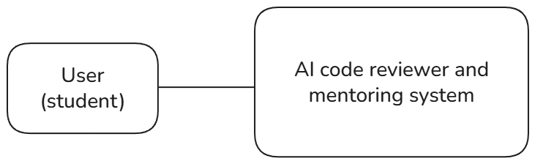
Brief description
The user (i.e. student) writes his code for a DSA question, the DSA question, and its category. This data is sent to the backend, which returns an analysis of his code and approach along with a grade and flaws of his approach which he should try to overcome.
Initial Step-By-Step Description
Before this use case can be initiated, the student has already accessed the Text editor of the website.
- The Student first pastes the question in the question section which will be at the top of the page.
- Then in the text editor, the student writes his code, the progress he makes is logged (variable and function declarations).
- After the student finishes writing his code, he clicks on the review button
- The button sends a POST request to the backend with question, code, coding logs and time spent per line.
- Backend responds with a list of possible approaches the student might be taking, such as approach A, approach B, approach C…. in order of decreasing probability of being the student’s intended approach.
- The Student selects the approach he used, another request will be sent to the server.
- The server will respond with explanation with why that approach is ineffective and also a hint towards how it can be improved.
<Step 5 & 6 comes from the assumption that AI will not be 100% accurate in exactly deducing the student’s thought process with the provided information and it gives students the option to specify his approach.
Those steps will be omitted if AI is able to determine the exact thought process by itself.>

2.3 User Characteristics
The users are students intending to learn problem solving and data structures and algorithms (DSA). They are expected to have basic programming knowledge, familiarity with at least one programming language and the ability to understand algorithmic concepts and data structures.

2.4 Non Functional Requirement
- The interface will be simple and easy to navigate for students with basic programming knowledge.
- The final response should be an analysis of all the information that will help students develop better understanding and intuition for solving questions more effectively.
- The system should be replicable for all patterns of questions without redesigning core logic. It should also have the scope of extending it to other domains of computer science Engineering
- 5-10 sec response time.
- Scalable to any company standard code review
- Neutral/universal color UI

Future scope: should work with IDEs, lightweight

3.0 Requirement Specification

3.1 External Interface Requirements
User Interface: The system is accessed externally via a web-based text editor. Users can enter a problem, write a solution for it, and submit it by clicking the “Review” button.
Communication Interface: All client-server communication shall occur over HTTPS. Data formats for requests and responses shall be standardized as JSON.
Secure, xrr owasp, csrp tokens
External API: The system sends the question, code, logs, time spent per line to the LLM api, which helps it better determine the student’s approach and grade the approach.

3.2 Functional Requirements
3.2.1 Code Analysis
Use Case | Code Analysis
Xref | Section 2.2
Trigger | The user clicks the review button after finishing his code
Precondition | The person has written the code and the question in the given sections
Basic Path | - User should be able to enter the question through a text box.  - User should be able to select category of the question through a dropdown  - Users should be able to write the code for the question in a text editor.  - System should log the data as soon as user starts writing the code.  - Review button is clicked  - The code is submitted along with logs, time spent, the question and its type.  - Backend forwards the data to the LLM, along with error types associated with the question category.  - LLM responds with error type if there are any.  - The backend returns the error details to the student.  - If there are no errors, LLM will return a list of possible approaches students might have taken.  - This list will be forwarded to the student and he’ll choose the approach he took.  - It goes to the Backend then to the LLM.  - LLM responds with the cons of that approach and hints towards the right approach  - The LLMs response is forwarded to the Student
Postcondition | The student gets the AI generated review for the code

